**TRAFFIC MANAGEMENT SYSTEM**

**DIAGRAM:**

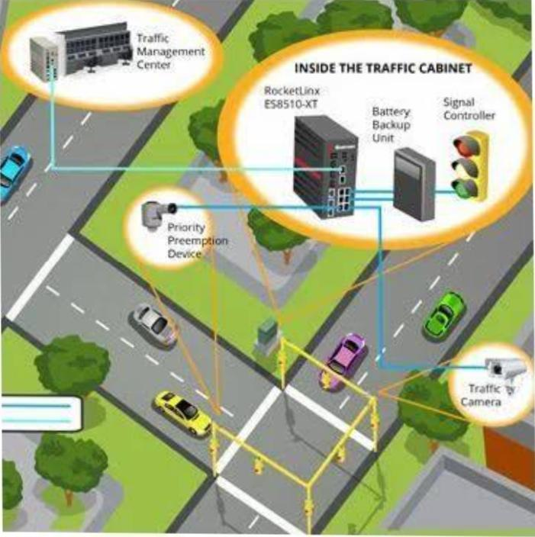

**ABSTRACT:**

***Traffic Signal Management System represents a transformative approach to urban traffic control. By utilizing advanced IoT technology, it revolutionizes how traffic signals operate. Real-time data from sensors at intersections informs the system, allowing for dynamic adjustments to signal timings based on traffic conditions. This adaptability significantly reduces congestion, decreases travel time, and improves overall traffic efficiency. This innovative system not only benefits commuters but also contributes to safer roads and more sustainable urban environments, aligning with the vision of intelligent and responsive traffic signal management.***

***IoT-Based Traffic Management System is a cutting-edge solution for assessing urban traffic challenges. Through a network of strategically placed sensors and sophisticated data analytics, it optimizes traffic flow, reduces congestion, and enhances road safety. The system’s adaptability in real-time signal control and its ability to provide timely information to drivers make it a cornerstone for smarter, more efficient urban transportation. By leveraging IoT technology, this innovative system takes us a step closer to realizing the concept of intelligent and sustainable cities with responsive traffic management solutions that prioritize the well-being of both commuters and the urban environment.***

**PROGRAM:**

**#include <stdio.h>**

**#include <stdlib.h>**

**#include <time.h>**

**#include <unistd.h>**

**Typedef enum { RED, GREEN, YELLOW } TrafficLightState;**

**Void delay(int seconds)**

**{**

**Time_t start_time = time(NULL);**

**While (time(NULL) < start_time + seconds);**

**}**

**Void changeTrafficLight(TrafficLightState* state)**

**{**

**If (*state == RED)**

**\*state = GREEN;**

**Else if (*state == GREEN)**

**\*state = YELLOW;**

**Else**

**\*state = RED;**

**}**

**Int main()**

**{**

**TrafficLightState trafficLight = RED**

**For (int I = 0; I < 10; i++)**

**{**

**Printf(“Traffic light is %s\n”, trafficLight == RED ? “RED” : (trafficLight == GREEN ? “GREEN” : “YELLOW”));**

**Delay(2); // Simulate a 2-second interval**

**changeTrafficLight(&trafficLight);**

**}**

**Return 0;**

**}**